**Week 1 Deliverables:**

**Internship on Exhaustive Analysis of Indian Agriculture Sector Using Power BI**

**Overview of Week 1 Learning**

The primary aim of this internship is to create an exhaustive analysis dashboard for the Indian agriculture sector using Power BI. In the first mentoring session, we explored the foundational features of Power BI and performed basic data operations step by step. Below is a summary of the key concepts and tasks covered:

**Key Concepts Learned:**

1. **Power BI Interface Overview**:
   * We started with a blank Power BI report interface.
   * Explored the visualization pane on the right, which contains various chart types for creating visualizations.
   * Understood the functionality of the home tab for accessing core options like loading datasets.
2. **ETL Process in Power BI**:
   * **Extract**: Pulling data from sources like CSV files. This involves identifying the correct dataset and ensuring it is in a compatible format for Power BI.
   * **Transform**: Preprocessing data, including cleaning, handling missing values, and removing unnecessary information. During this step:
     + Unnecessary columns, such as identifiers or metadata not useful for analysis, were removed.
     + Blank columns and those deemed irrelevant to the dashboard objectives were also eliminated.
     + Data quality issues, such as null values or duplicate entries, were addressed to ensure consistency.
   * **Load**: Loading cleaned and processed data into Power BI for further analysis and visualization.
3. **Data Views in Power BI**:
   * **Report View**: For creating and interacting with visualizations.
   * **Table View**: For reviewing raw data and understanding its structure.
   * **Model View**: For building relationships among datasets to enable advanced analytics.
4. **Power Query Editor**:
   * Accessed via the Transform Data button in the Home tab.
   * Used for data cleaning, removing duplicate or null values, and transforming data types.

**Tasks Performed in Week 1:**

1. **Loading Data**:
   * Opened a CSV file using the "Get Data" option from the Home tab.
   * Selected the CSV file and explored options to Load or Transform the data.
2. **Data Transformation**:
   * Opened Power Query Editor to preprocess the dataset.
   * Removed unnecessary columns, including those with blank values or data irrelevant to the analysis objectives, by selecting and clicking "Remove."
   * Checked for null values using the "Column Quality" feature under the View tab.
   * Handled issues like duplicates, blank rows, and errors using options like Remove Duplicates and Remove Errors.
   * Adjusted data types for columns to ensure consistency and compatibility with Power BI visualizations.
   * Ensured that the cleaned data was structured properly for analysis by reorganizing or renaming columns as needed.
3. **Saving the Transformed Data**:
   * After completing the data cleaning process, saved the changes and loaded the transformed data into Power BI for visualization.

**Screenshots:**

*Include screenshots of the following tasks performed:*

1. Loading a CSV file in Power BI.
2. Power Query Editor interface showing data cleaning steps.
3. Column Quality feature in Power Query Editor.
4. Final dataset after transformation.

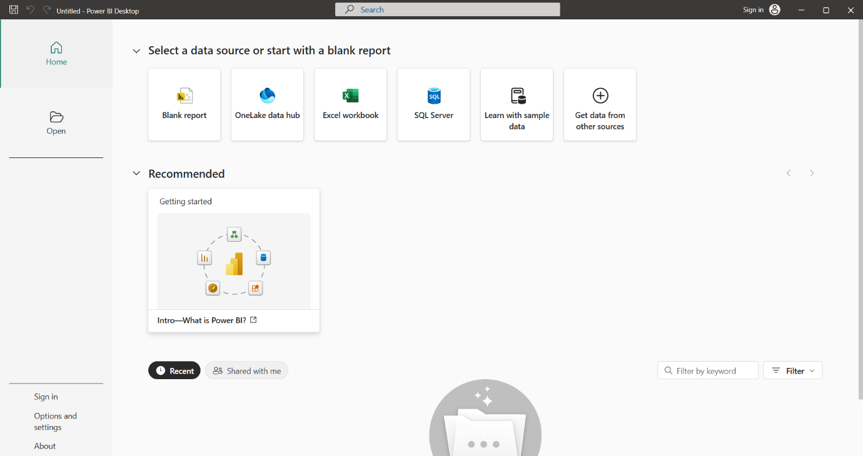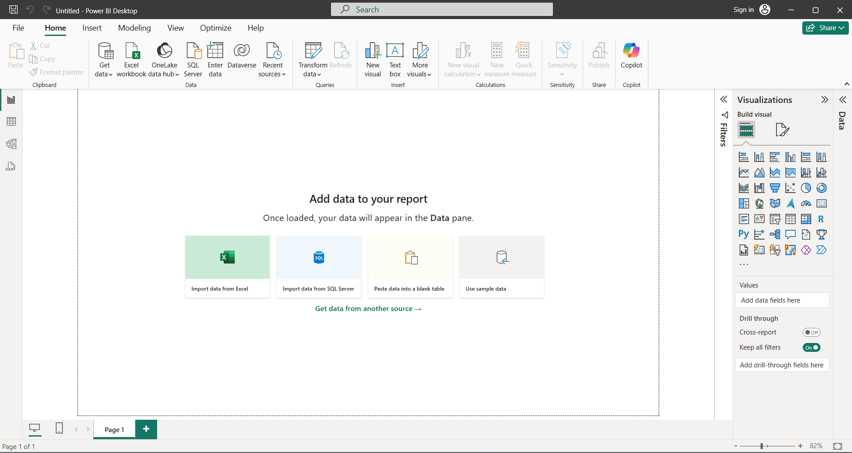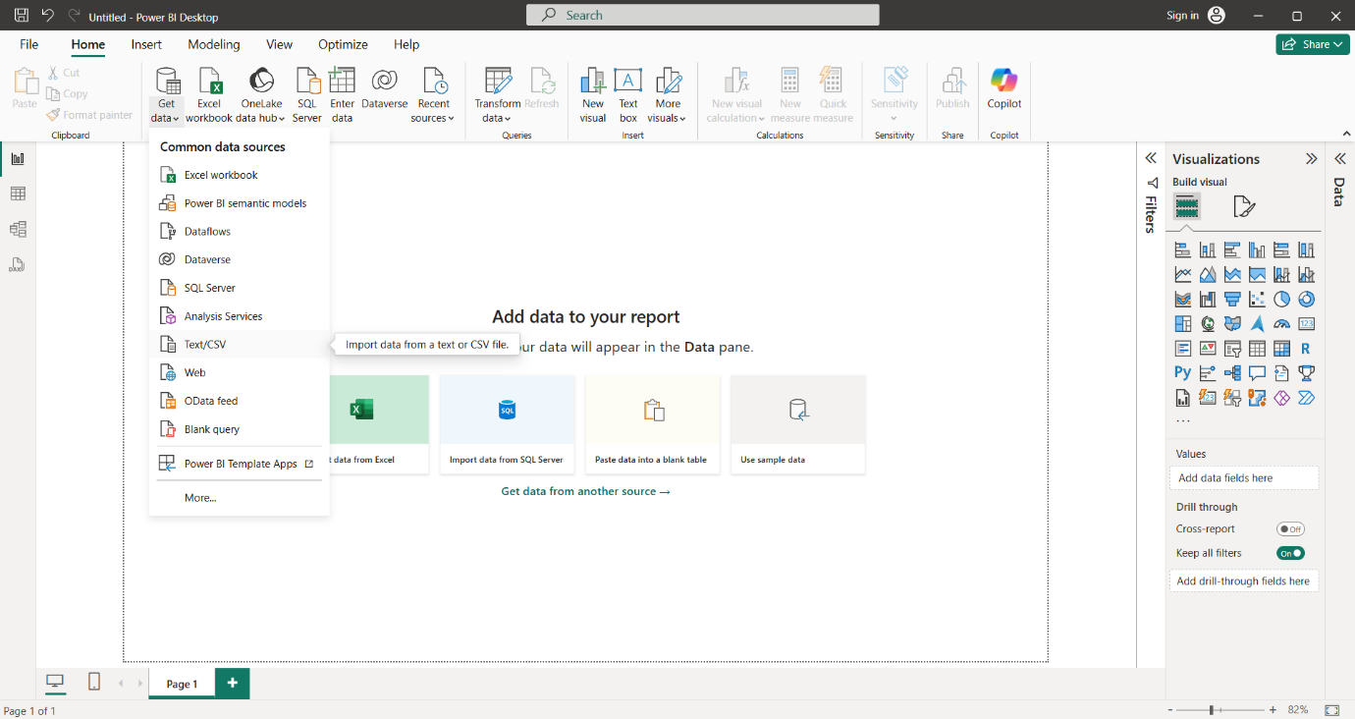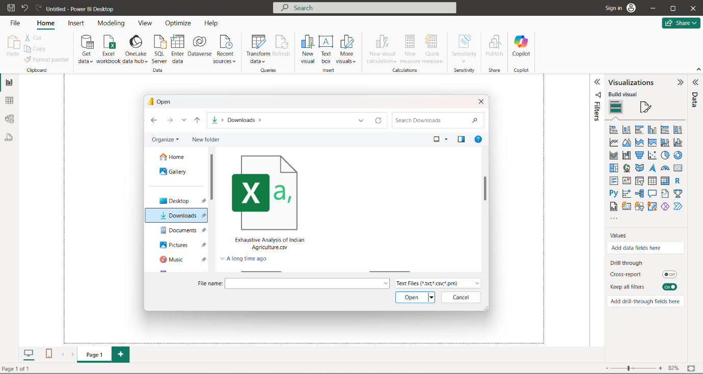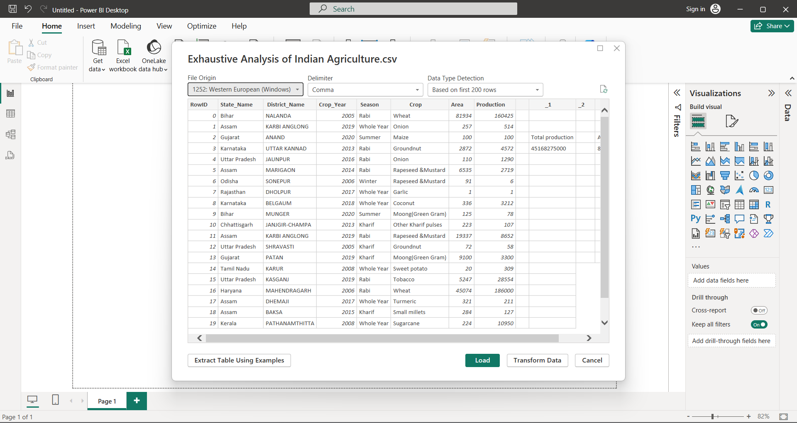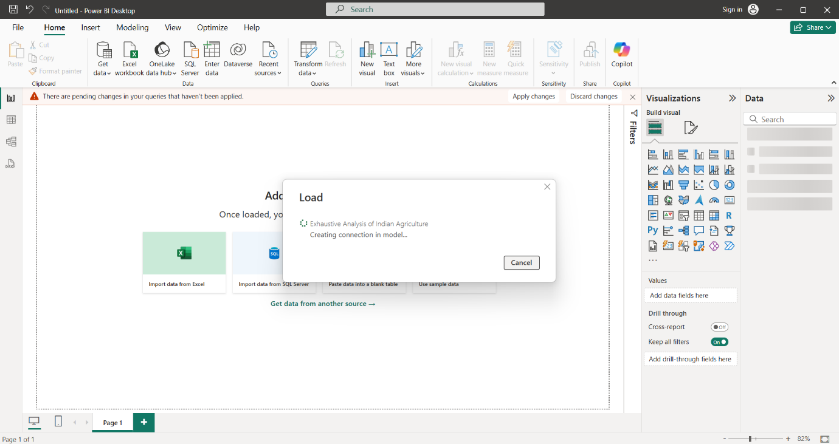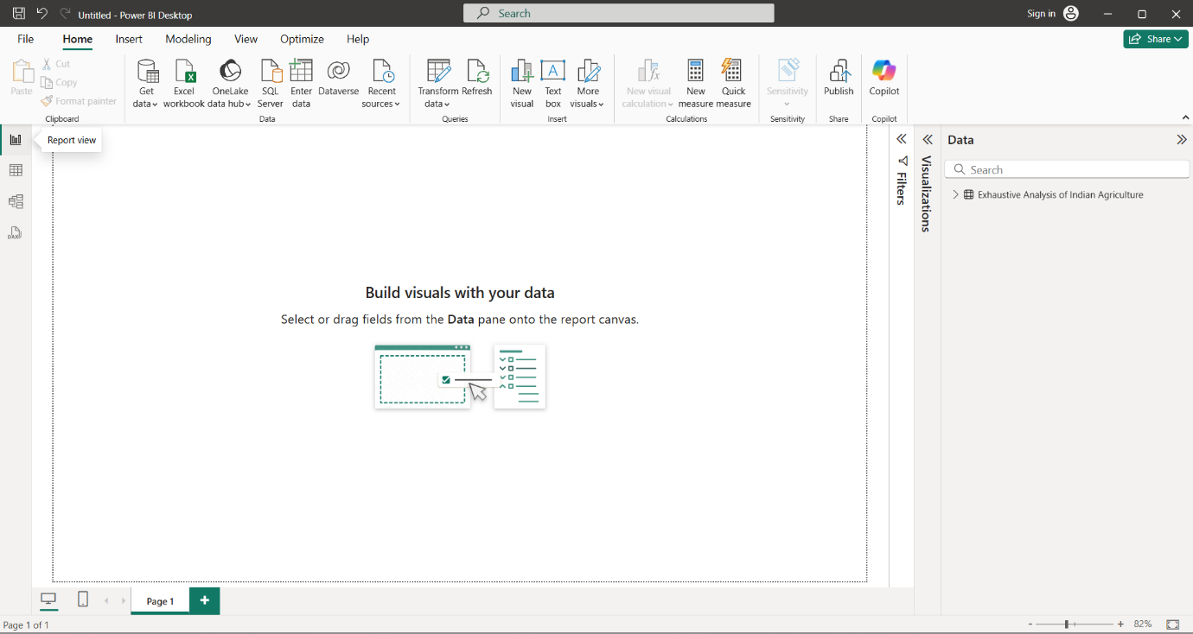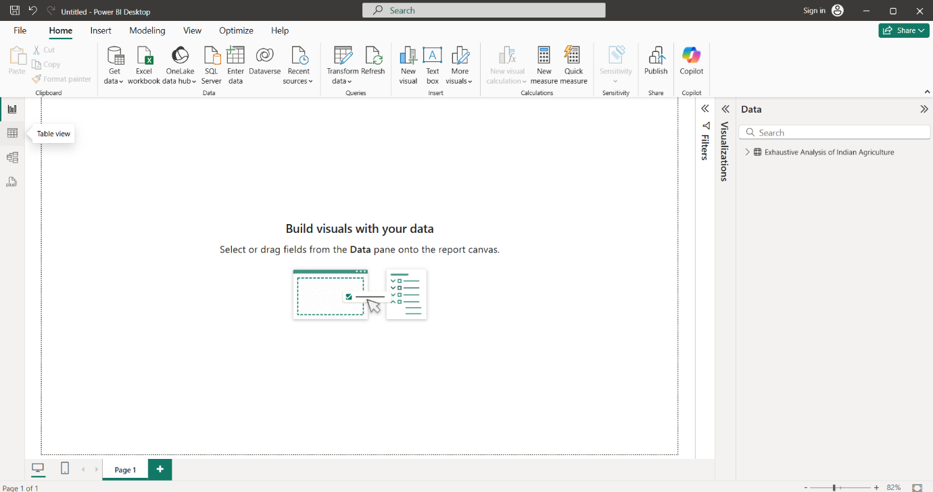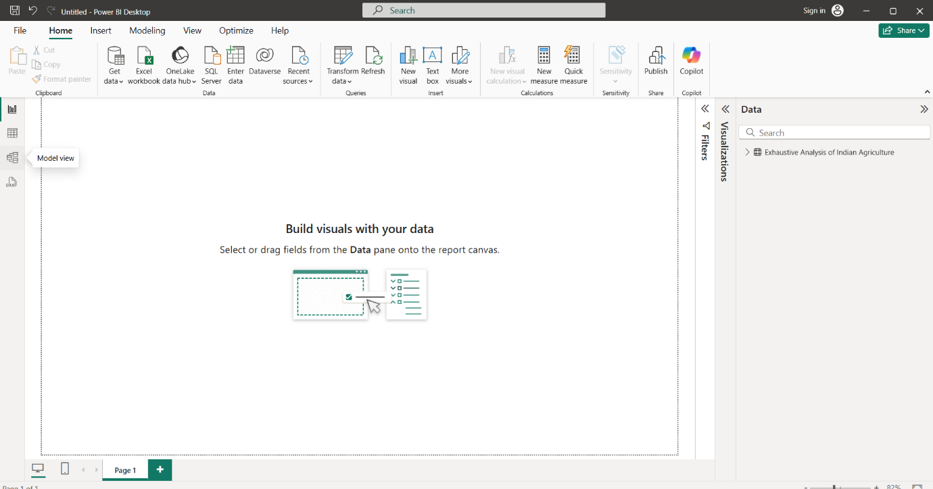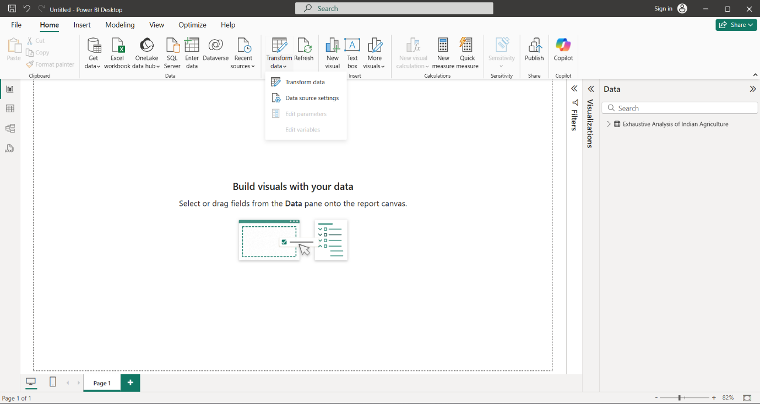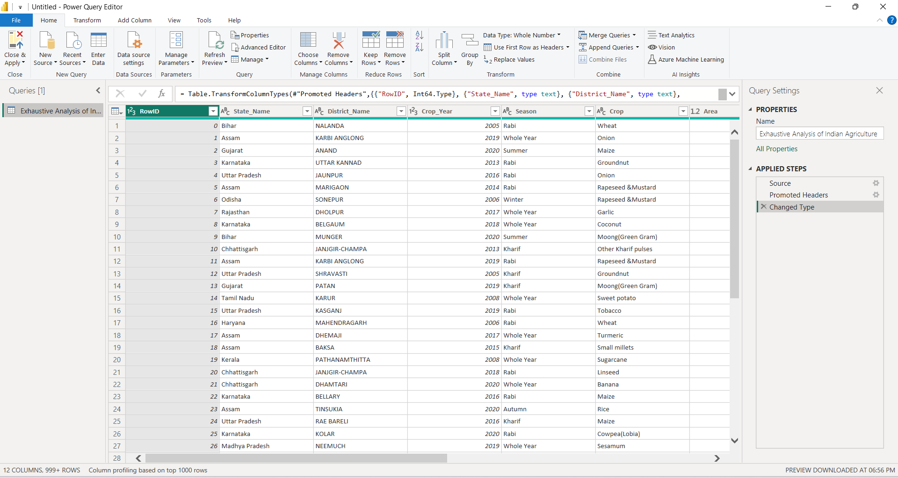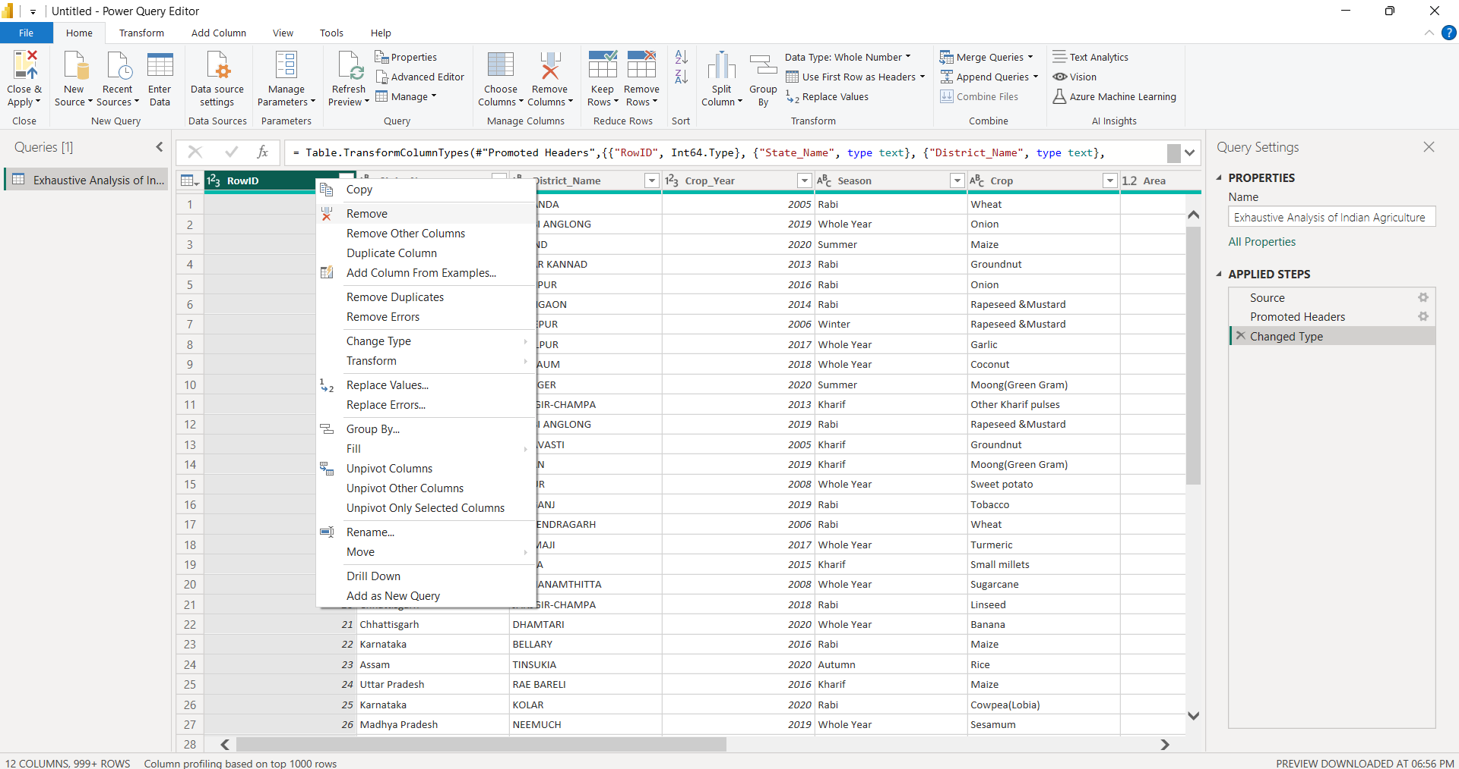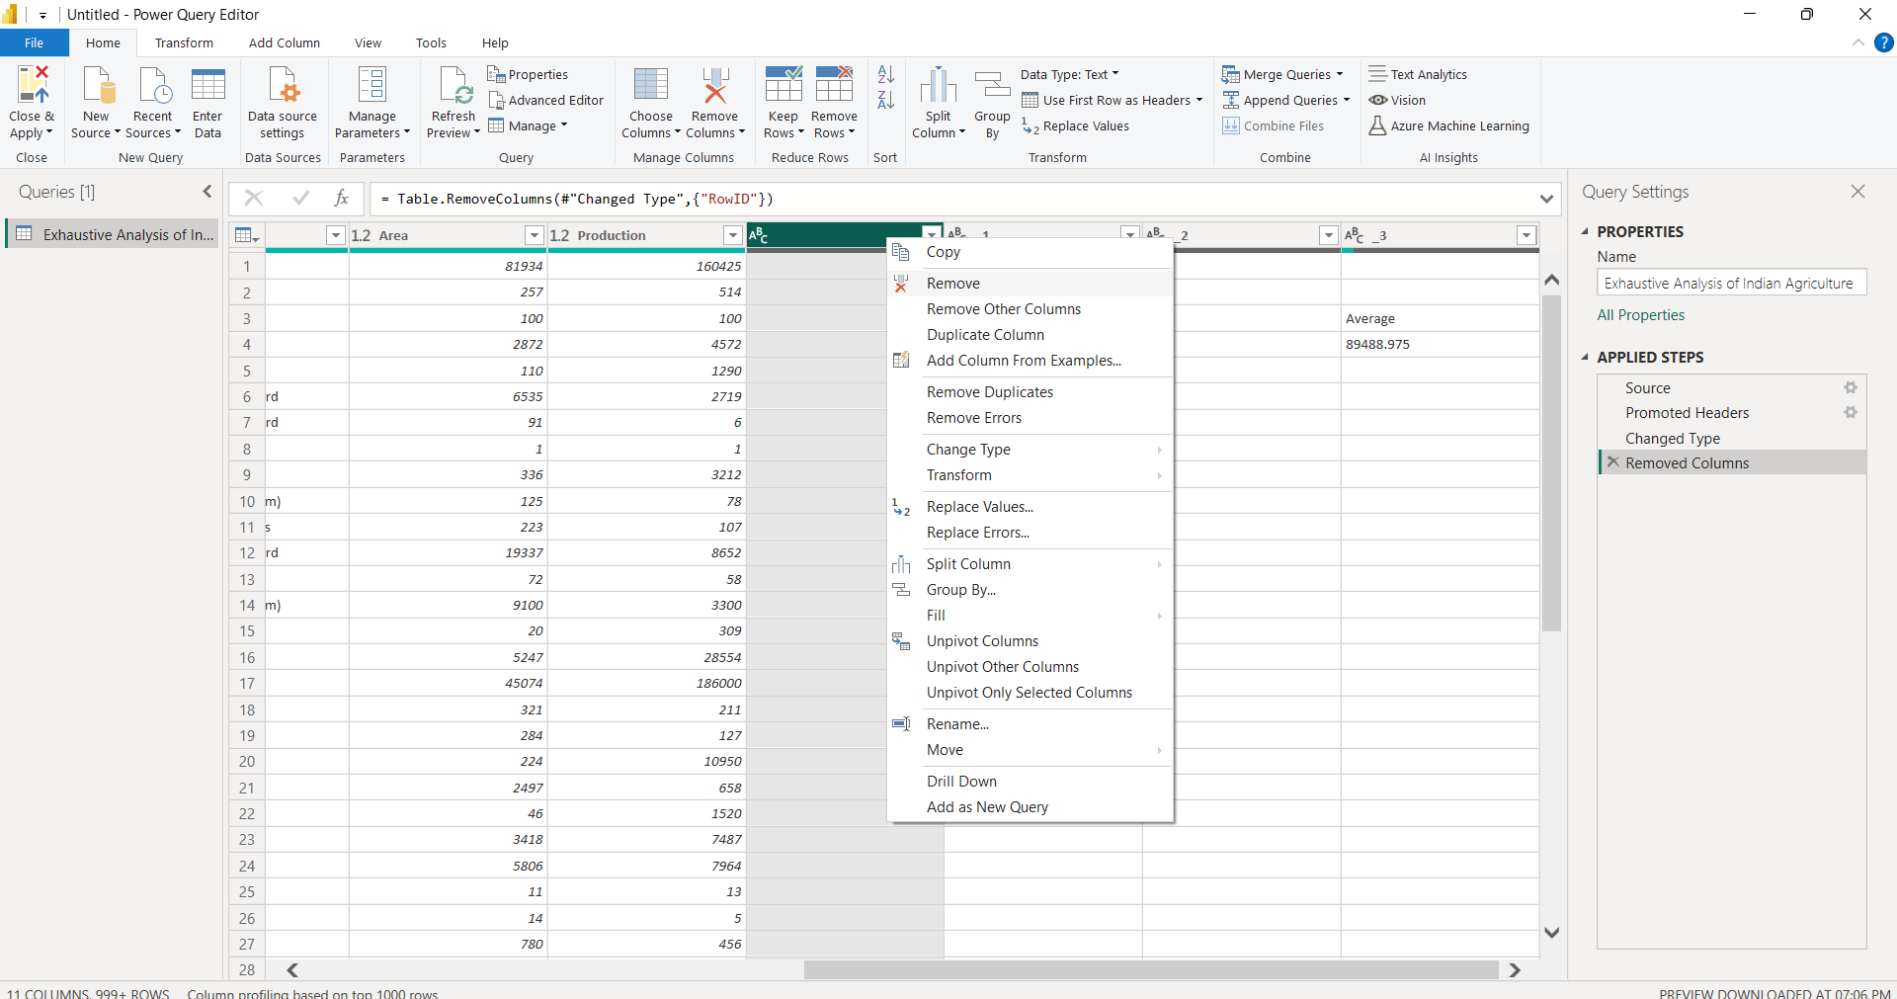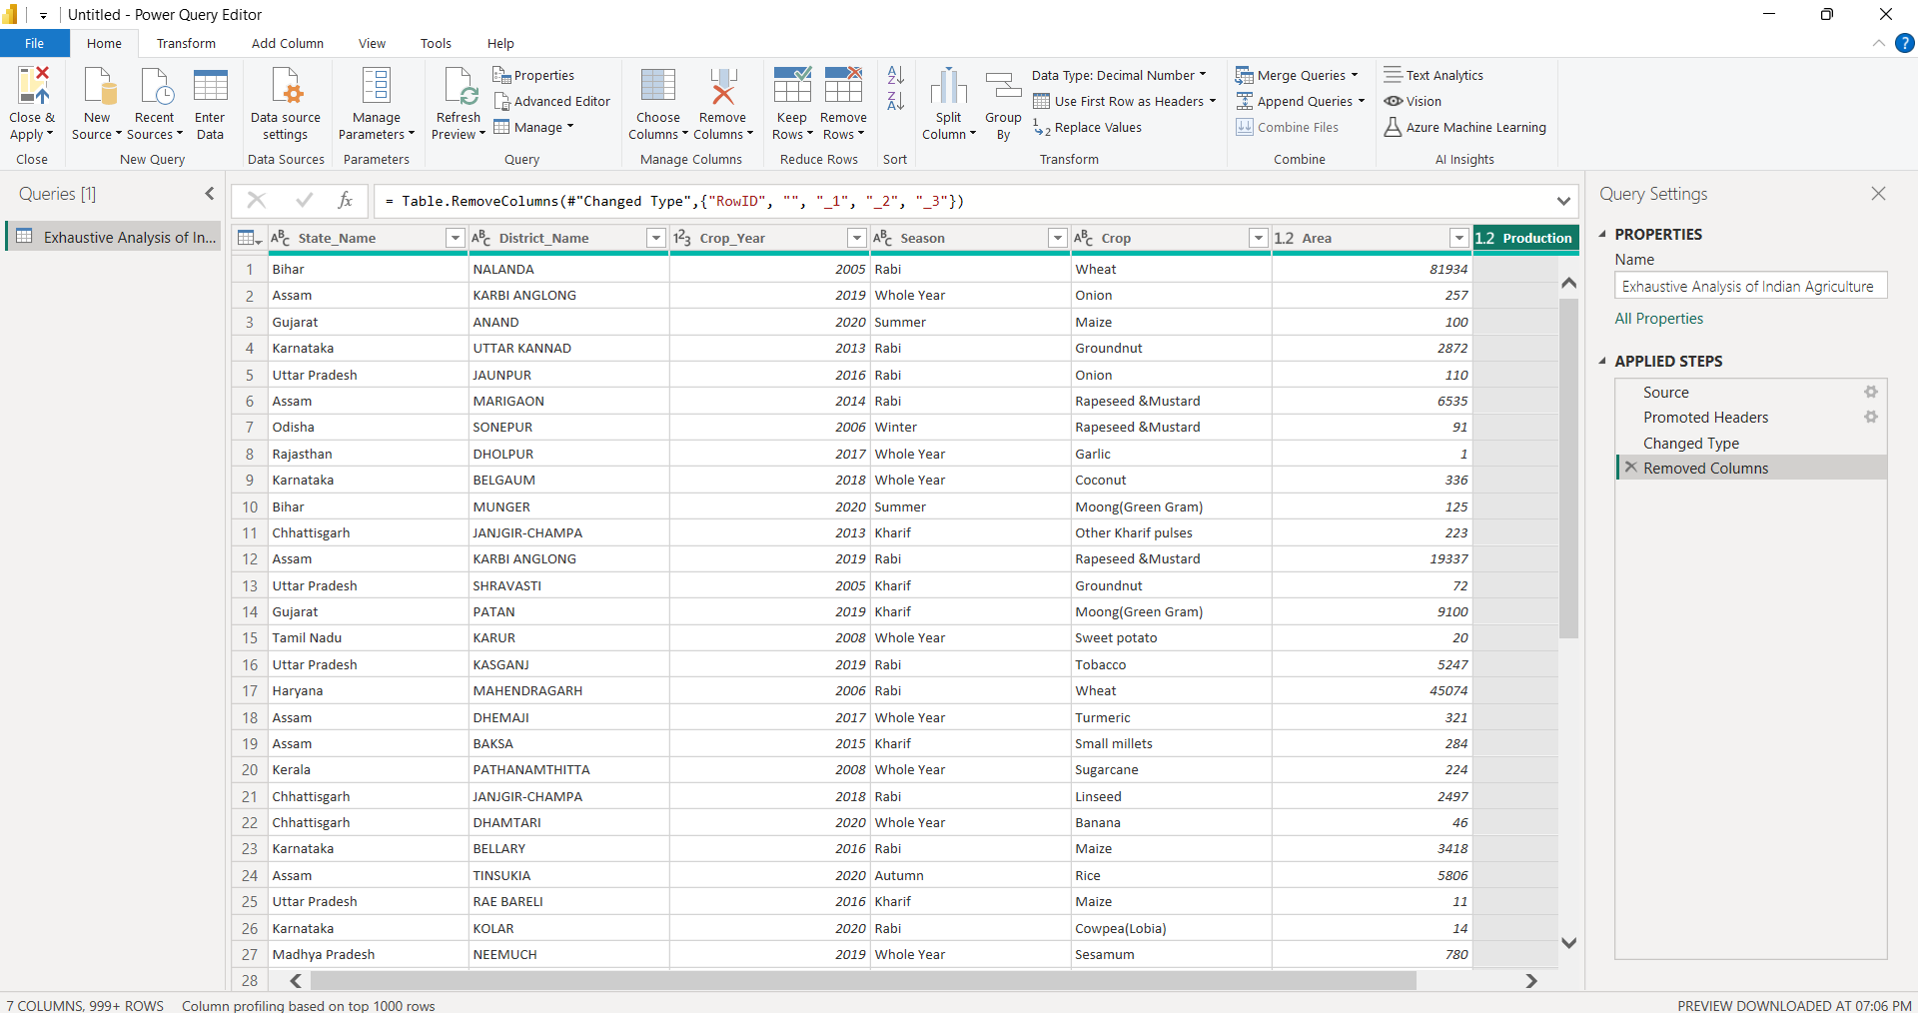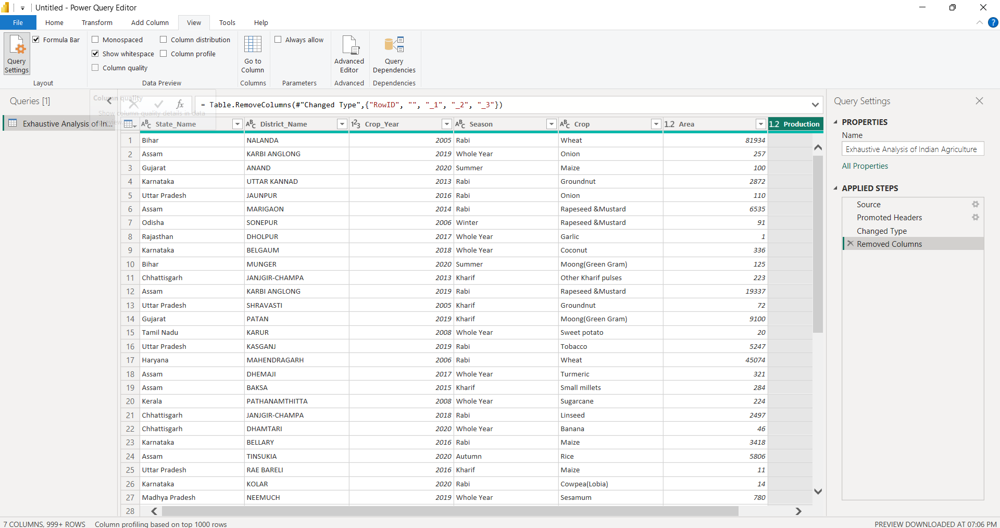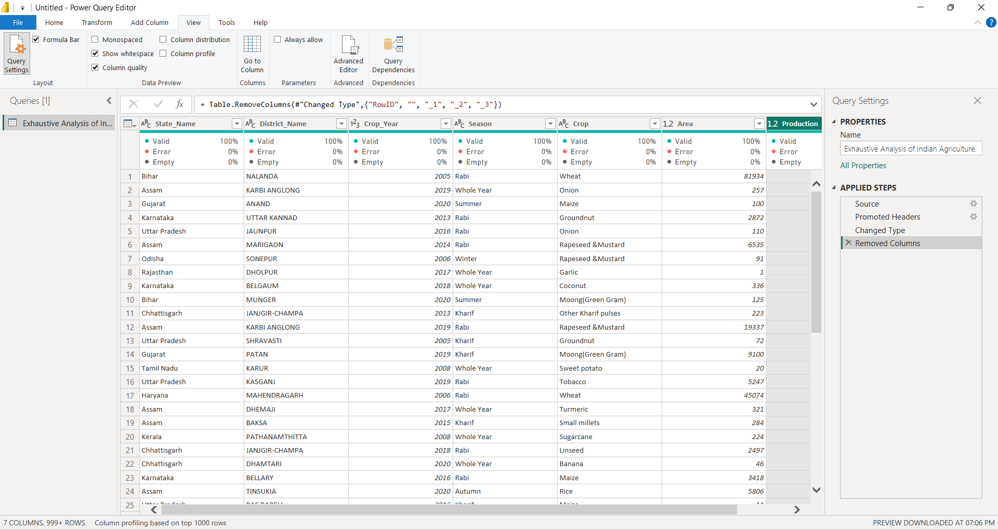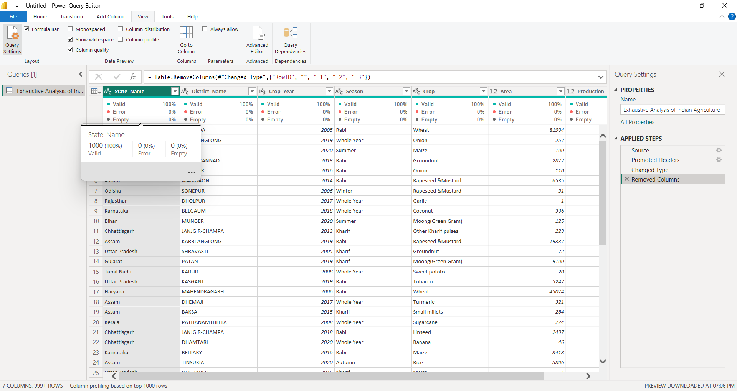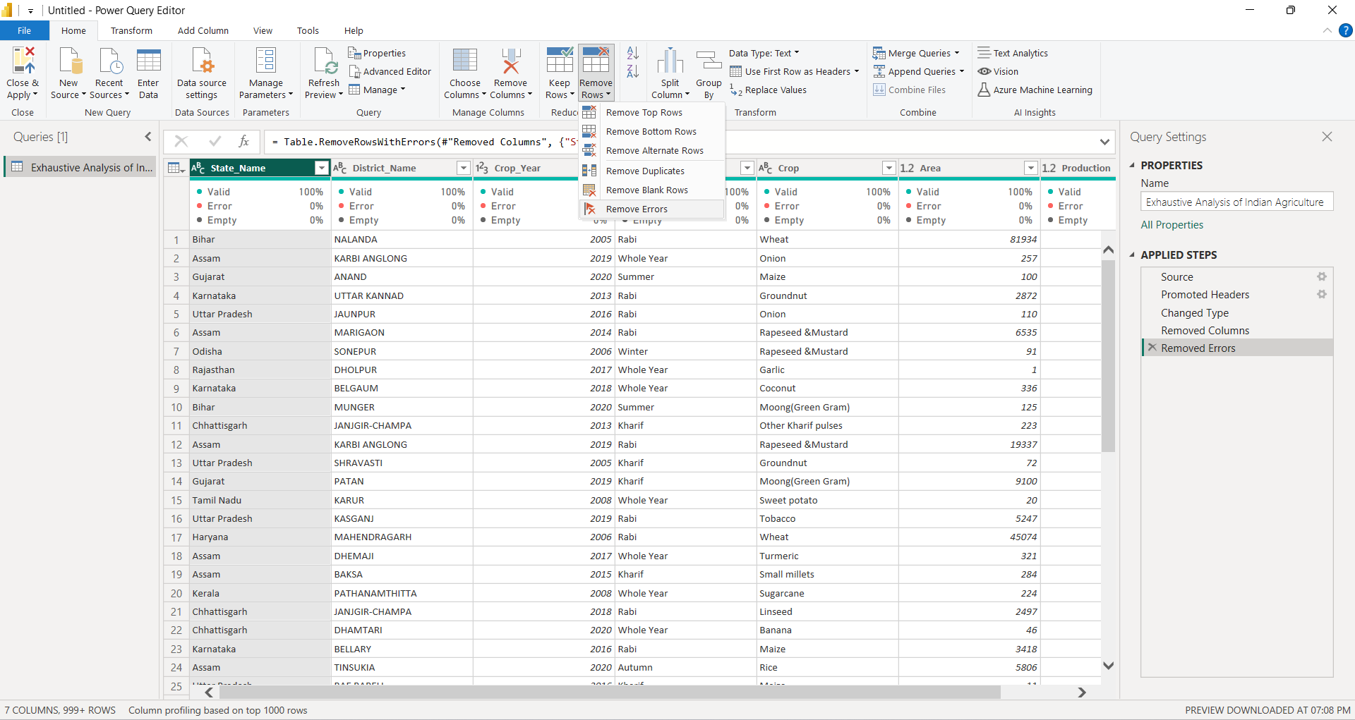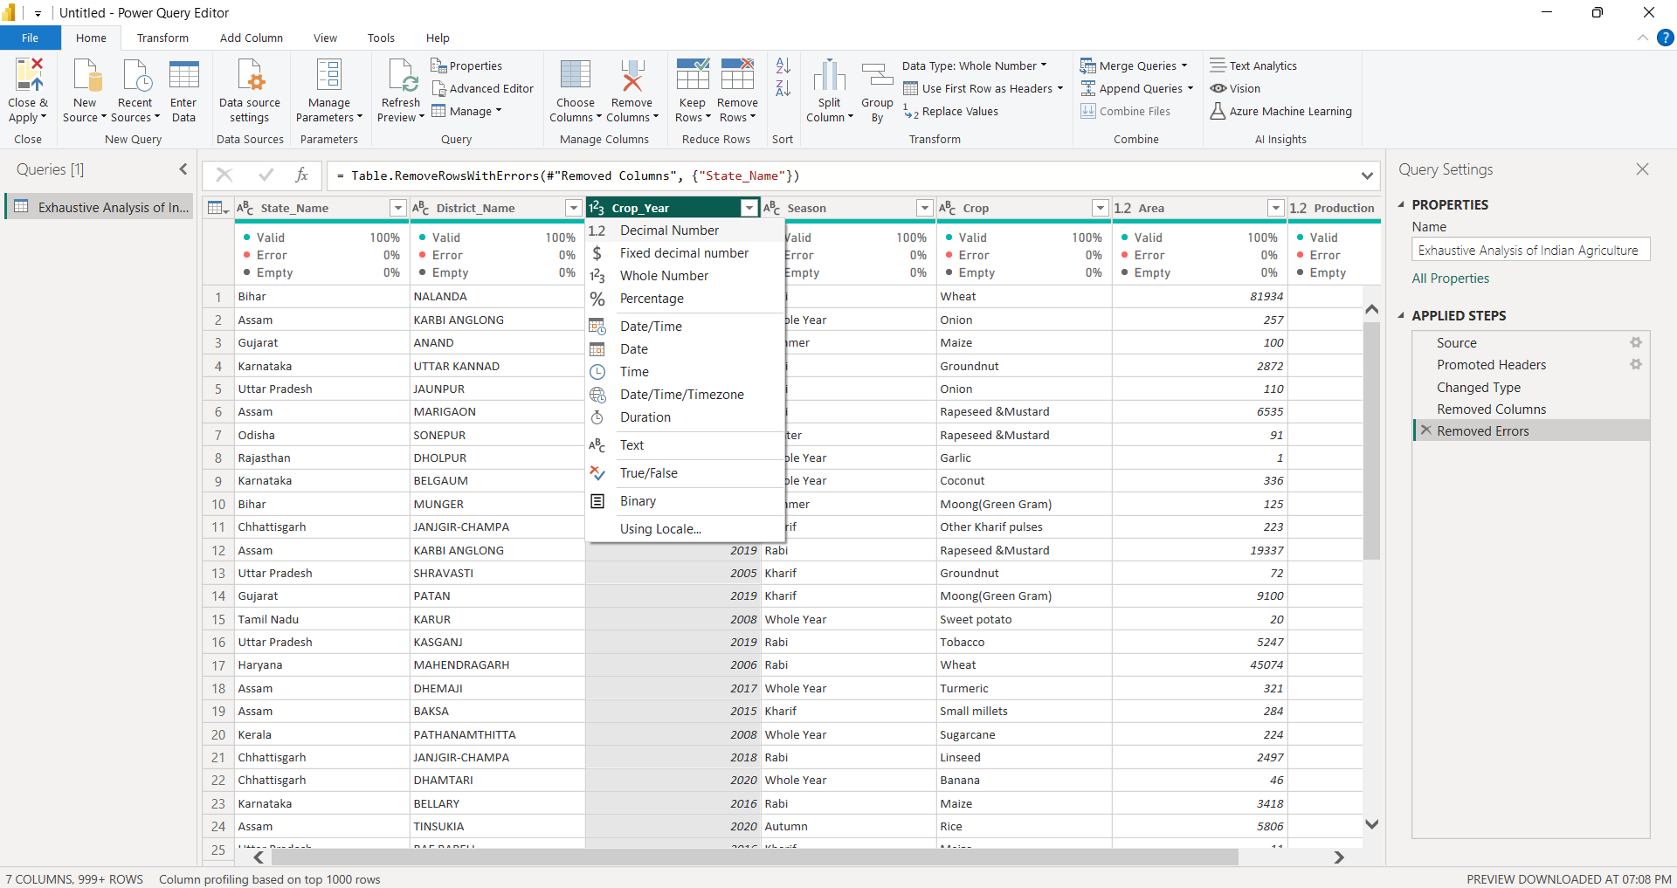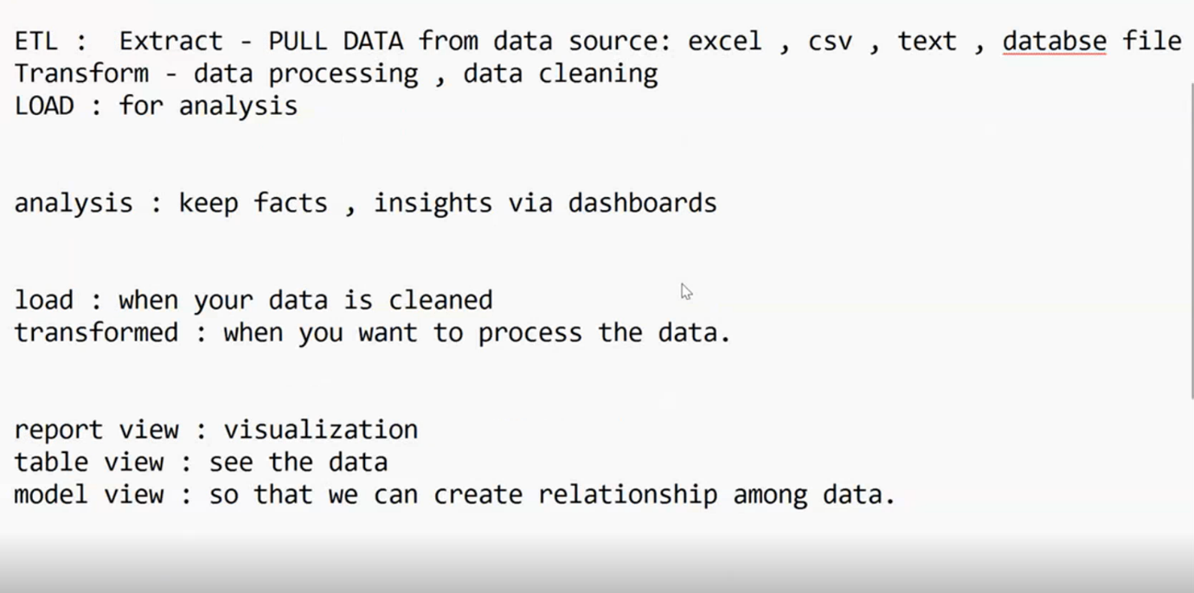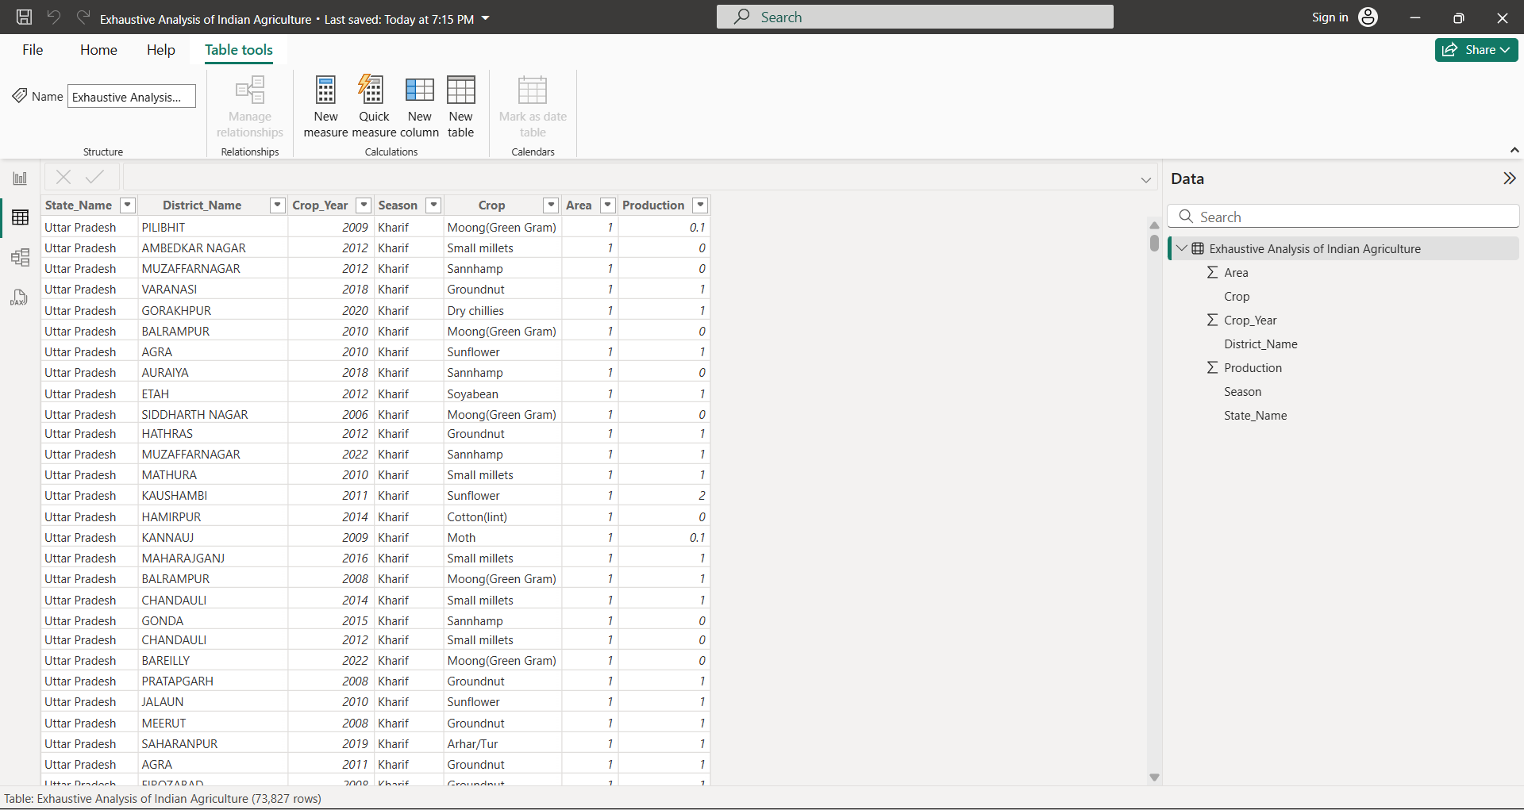

**Conclusion:** In the first week, we gained a solid understanding of the Power BI interface and the essential steps of the ETL process. These foundational skills will be instrumental as we progress toward creating the dashboard for the Indian agriculture sector.